LAB ASSIGNMENT-4

-- 1.

SELECT chr(65) from dual;

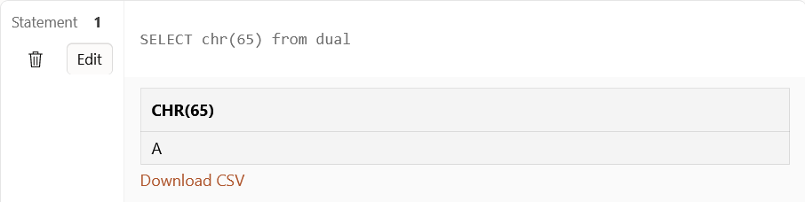

-- 2.

SELECT concat('hi',' world') from dual;

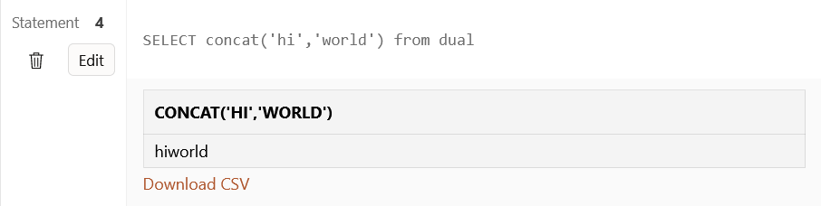

-- 3.

SELECT instr('hello','l') from dual;

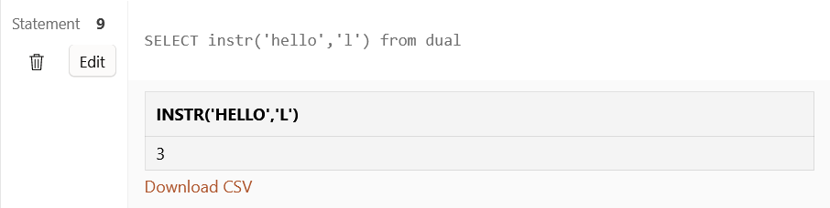

-- 4.

SELECT length(10) from dual ;

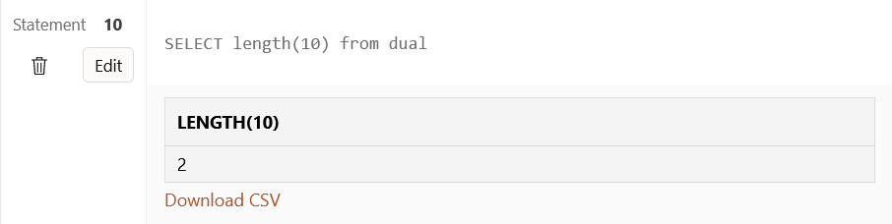

-- 5.

SELECT lpad('helloworld',20,'*') from dual ;

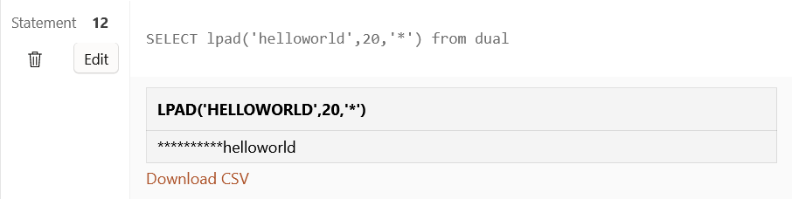

-- 6.

SELECT ltrim(' helloworld') from dual ;

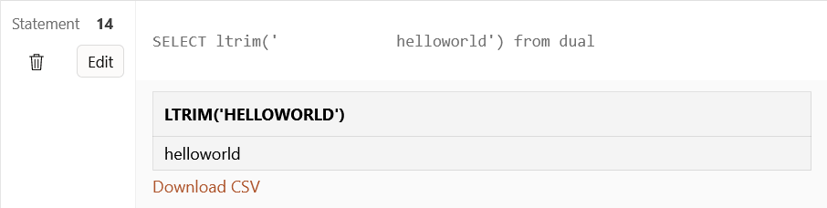

-- 7.

SELECT rpad('helloworld',20,'*') from dual ;

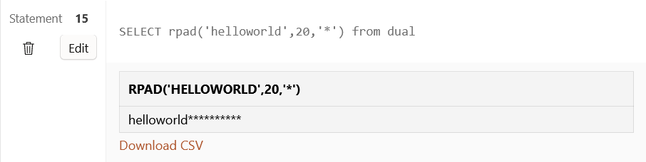

-- 8.

SELECT rtrim('hello world ') from dual ;

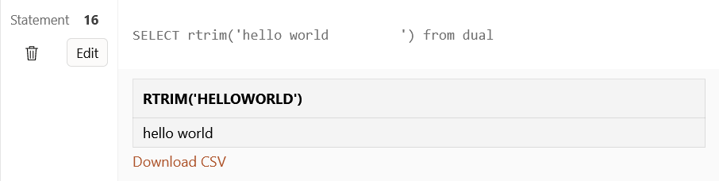

-- 9.

SELECT replace('C++ lab', 'C++','SQL') from dual;

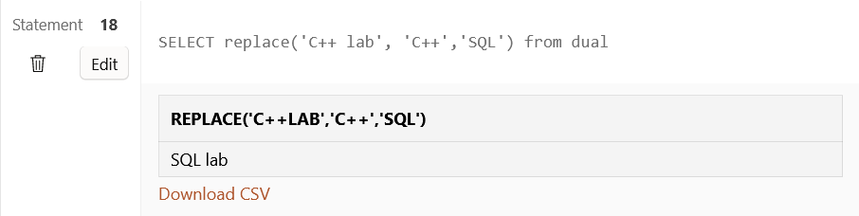

-- 10.

SELECT substr('hello world',7,5) from dual;

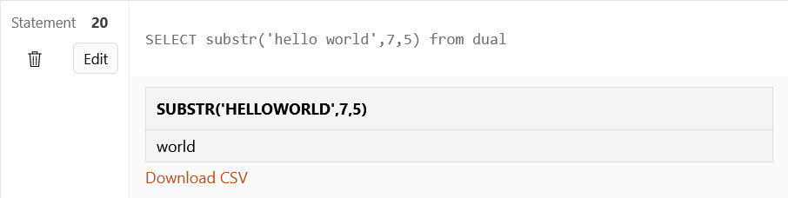

-- 11.

SELECT initcap('ishita nandwani') from dual;

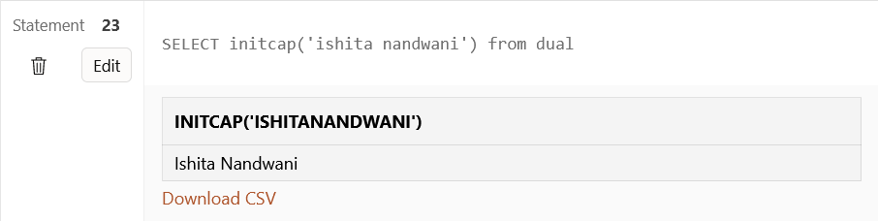

-- 12.

SELECT lower('HELLO WORLD') from dual;

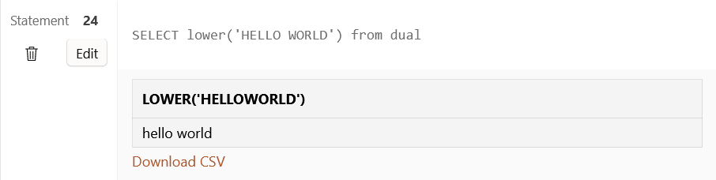

-- 13.

SELECT upper('hello world') from dual;

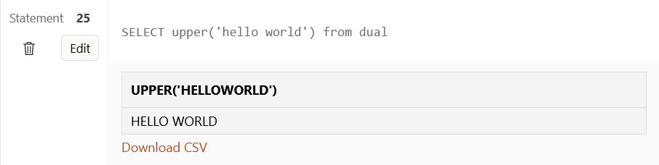

-- 14.

SELECT translate('Hola ','Hola ', 'Hello') from dual;

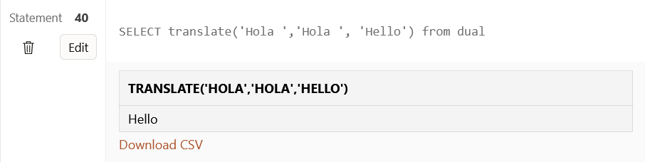

-- 15.

SELECT abs(-123.7) from dual

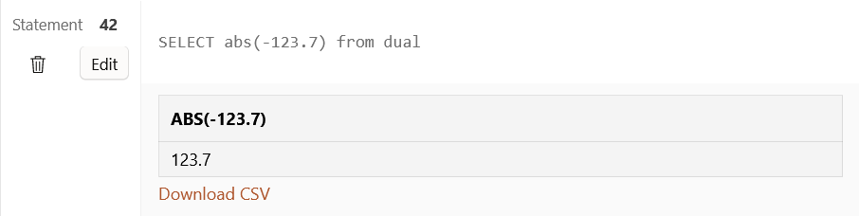

-- 16.

SELECT ceil(123.7) from dual

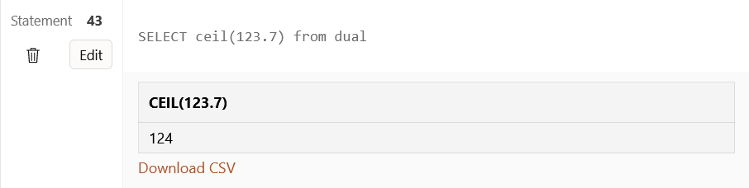

-- 17.

SELECT cos(0) from dual

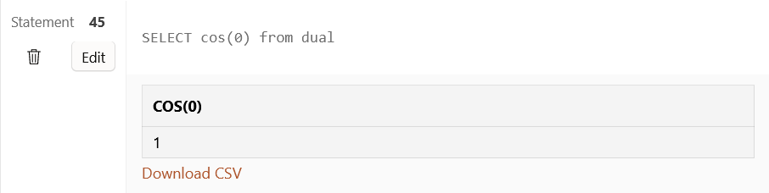

-- 18.

SELECT exp(1) from dual

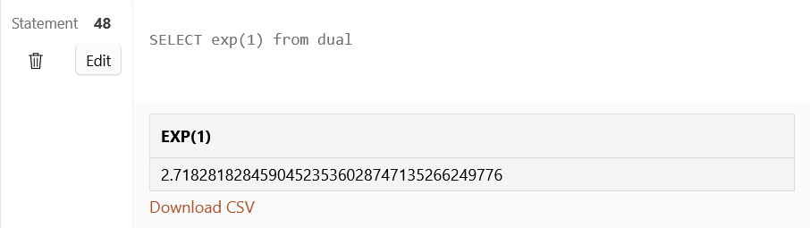

-- 19.

SELECT floor(123.7) from dual

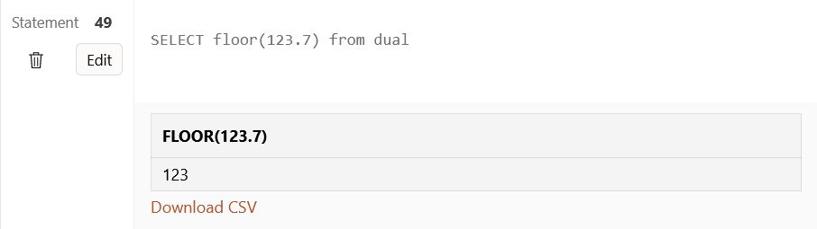

-- 20.

SELECT mod(17,4) from dual

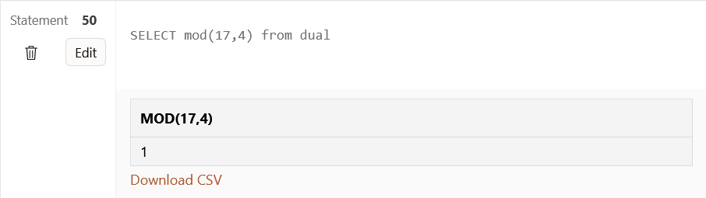

-- 21.

SELECT power(2,6) from dual

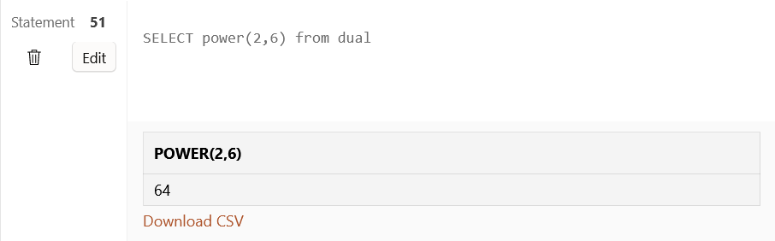

-- 22.

SELECT round(123.456,2) from dual

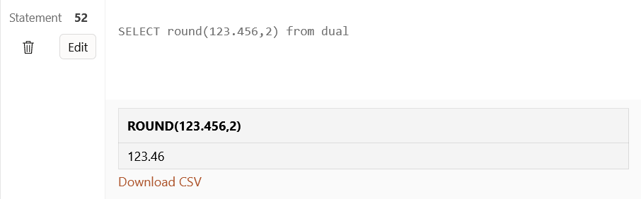

-- 23.

SELECT sign(-2) from dual

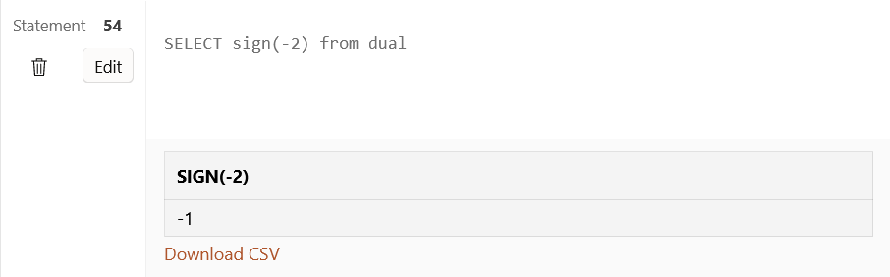

-- 24.

SELECT sqrt(81) from dual

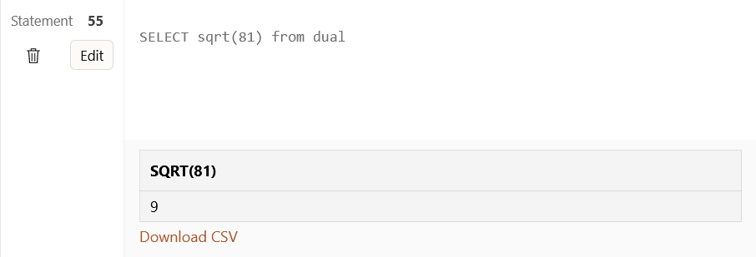

-- 25.

SELECT trunc(15,6) from dual

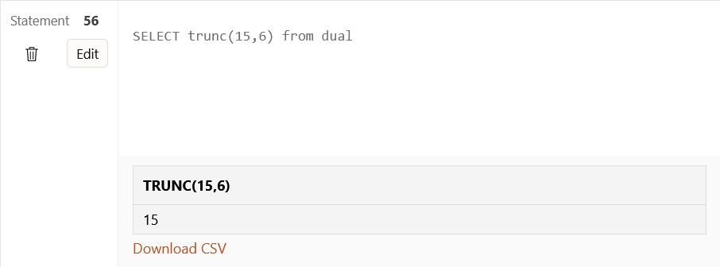

SELECT trunc(15.79,-1) from dual

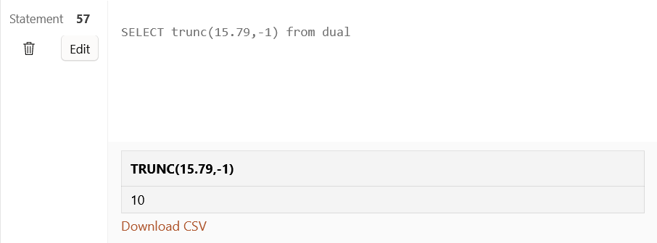

SELECT trunc(15.79,1) from dual

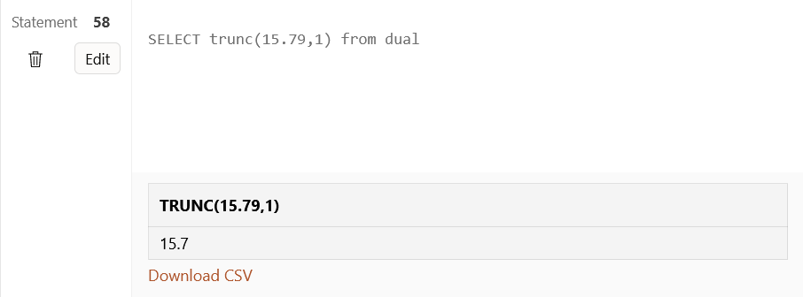

SELECT trunc(15.79,-2) from dual

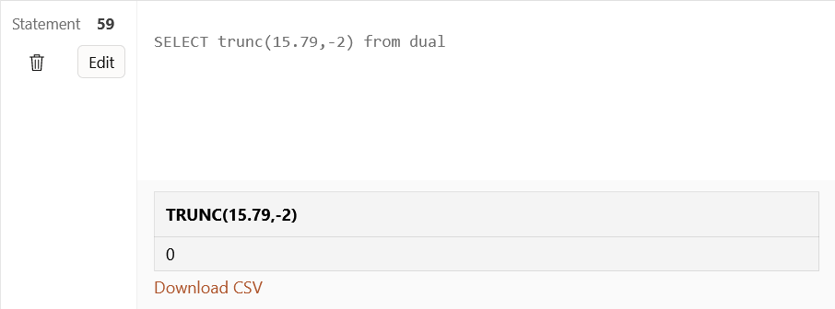

-- 26.

SELECT SYSDATE from dual

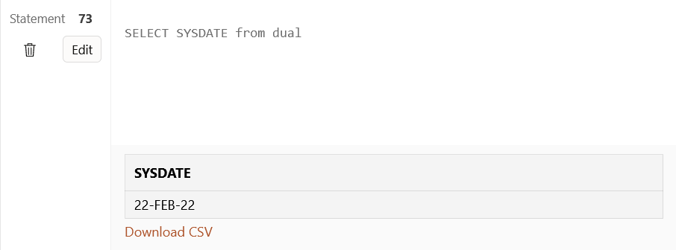

SELECT SYSDATE +1 from dual

SELECT SYSDATE +20 from dual

-- 27.

SELECT add_months('27-MAR-2001',9) from dual

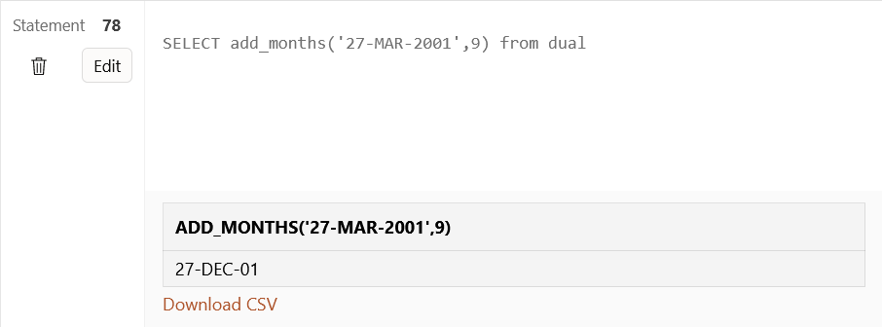

-- 28.

SELECT last_day('01-JAN-2022') from dual

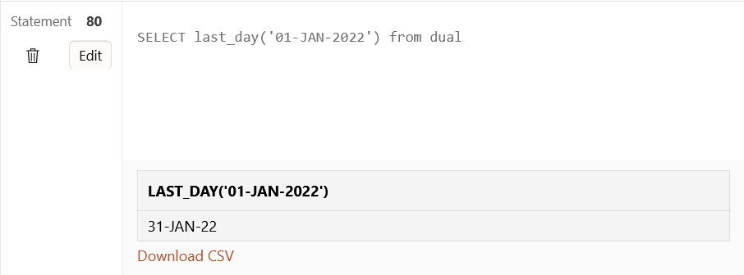

-- 29.

SELECT months_between('01-DEC-2023','01-JAN-2022') from dual

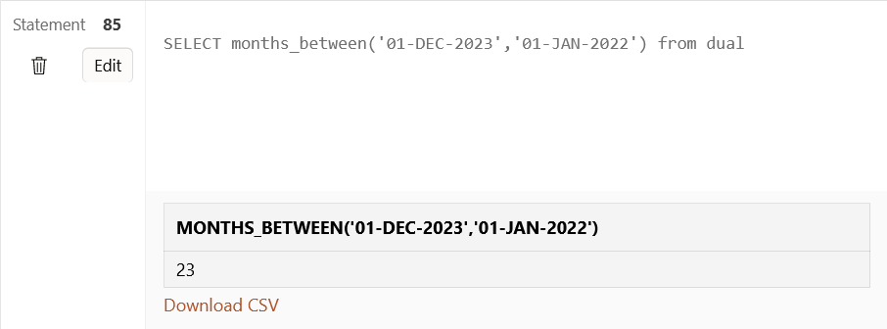

-- 30.

SELECT next_day('15-JAN-2022','MONDAY') from dual

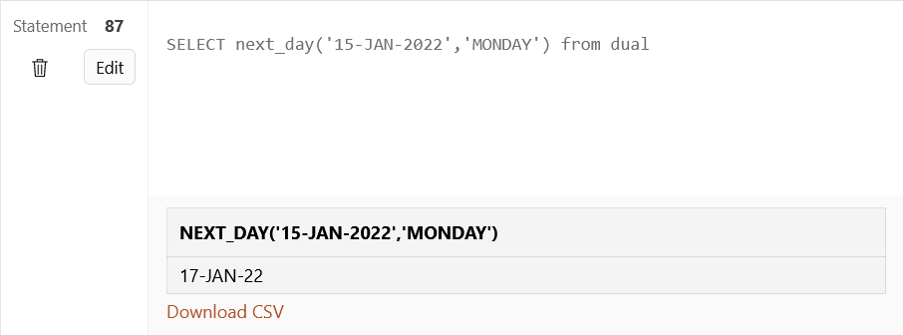-- 31.

SELECT greatest('11','18','09','23','28') from dual

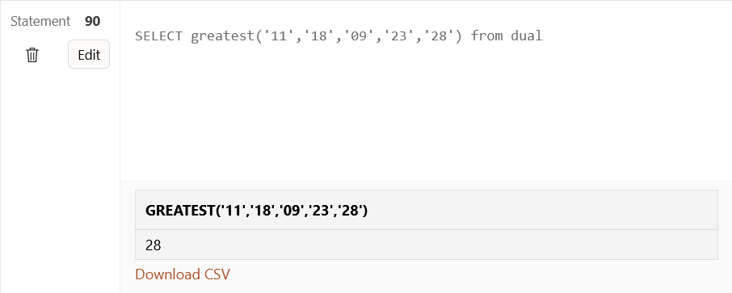

-- 32.

SELECT least('11','18','09','23','28') from dual

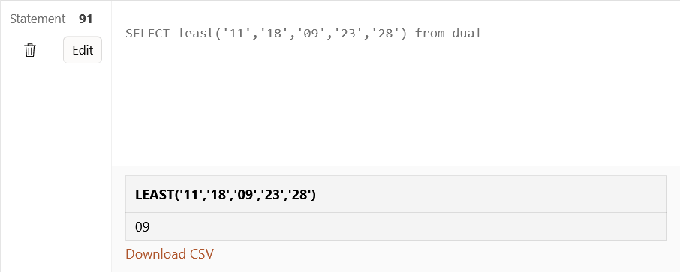

SELECT to_char(CURRENT_TIMESTAMP,'HH-MI-SS') FROM DUAL

